Git hub and Git bash group work of creating new repository successfully done: IRADUKUNDA Franco Nelly(L3 SOD A) and HAFASHIMANA Leonidas(L3 SOD A)

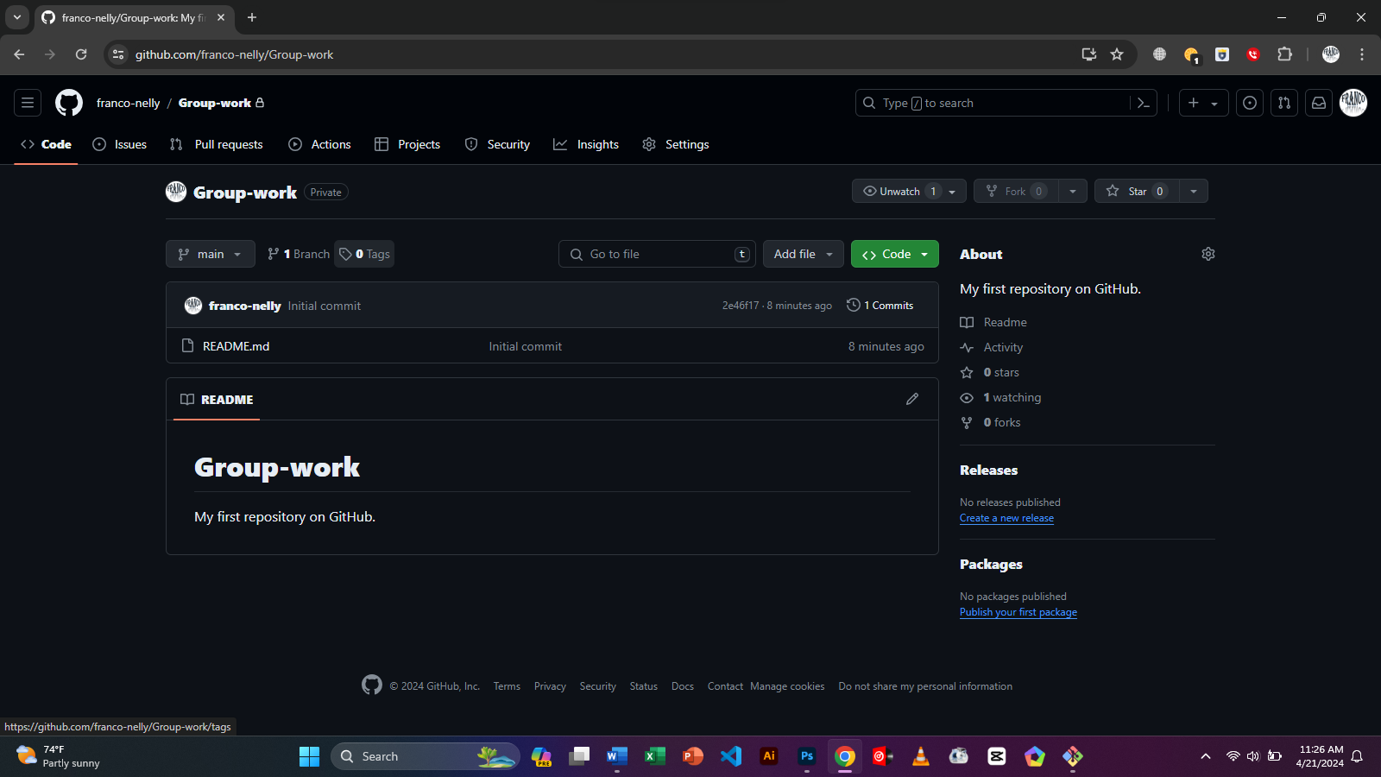

NELLY FRANCO@NELLY-FRANCO MINGW64 ~

$ git clone https://github.com/franco-nelly/Group-work.git

Cloning into 'Group-work'...

remote: Enumerating objects: 3, done.

remote: Counting objects: 100% (3/3), done.

remote: Total 3 (delta 0), reused 0 (delta 0), pack-reused 0

Receiving objects: 100% (3/3), done.

NELLY FRANCO@NELLY-FRANCO MINGW64 ~

$